**Assignment 5 : Group B (Unit III & IV )**

| **Oral (2)** | **Code (2)** | **Duration (2)** | **Varity(2)** | **Output (2)** | **Total** | **Sign** |
| --- | --- | --- | --- | --- | --- | --- |
|  |  |  |  |  |  |  |

**Date of Performance ____________**

**Date of Completion** :_____________

**Problem Definition: Understand the concept of Sub-netting & Subnet mask.**

**PROBLEM STATEMENT:**

**Write a program to demonstrate Sub-netting and find subnet masks.**

**6.1 Prerequisite:**

1. IP Address Classes

2. Classless & Classful IP Addressing

**6.2 Learning Objectives**:

1. Understand the concept Subneting.

2. Understand the Concept of Supernet.

**6.3 Theory**

**6.3.1 Introduction**

■ **A Unique, 32-bit address used by computers to communicate over a computer network**

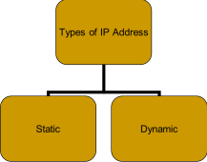

**Classes of Address**

■ **IP address structure consists of two addresses, Network and Host** ■ **IP address is divided into five classes**

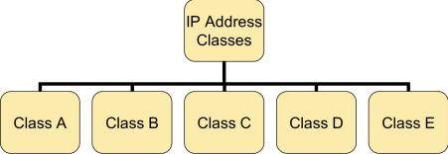**IP Address Classes**

**The 5 IP classes are split up based on the value in the 1st octet:** Class A: 0-127

Class B: 128-191

Class C: 192-223

Class D: 224-239

Class E: 240-2552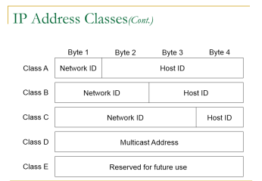

**Examples of IP Address**

14.23.120.8 - The first byte of the address represents 14 which lies between 0 and 127, hence Class A address. 

134.11.78.56 - The first byte of address is 134 which lies between 128 and 191 hence the address belongs to Class B. 

193.14.56.22 - As first byte is 193 which is between 192 and 223, hence the address belongs to Class C. 

**Subnet Mask**

An IP address has 2 parts:

* The Network identification.
* The Host identification.

Frequently, the Network & Host portions of the address need to be separately extracted.

In most cases, if you know the address class, it’s easy to separate the 2 portions.

■ Specifies part of IP address used to identify a subnetwork.

■ Subnet mask when logically ANDed with IP address provides 32-bit network address

**Default Mask:**

****Has predetermined number of 1s

Class A, B and C contains 1s in network ID fields for default subnet mask.

Computer Network laboratory (2015) Pattern TE Computer

| **Address Class** | **Default Mask**  **(in Binary)** |
| --- | --- |
| Class A | **11111111.00000000.00000000.00000000** |
| **Class B** | **11111111.11111111.00000000.00000000** |
| **Class C** | **11111111.11111111.11111111.00000000** |

**Default Standard Subnet Masks**

There are default standard subnet masks for Class A, B and C addresses: 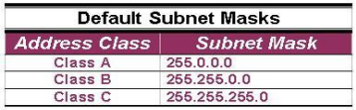

**IP Subnetting:**

■ Allows you to divide a network into smaller sub-networks

■ Each subnet has its own sub-network address

■ Subnet can be created within Class A, B, or C based networks

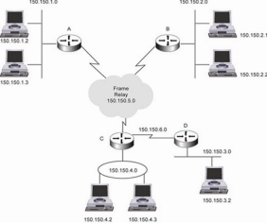

**Subnetting:**

■ Division of a network into subnets

* For example, division of a Class B address into several Class C addresses
* Some of the host IDs are used for creating subnet IDs

**Need for Subnetting:**

■ Classes A and B have a large number of hosts corresponding to each network ID

* It may be desirable to subdivide the hosts in Class C subnets

■ Often, there is a limitation on the number of hosts that could be hosted on a single network segment

* The limitation may be imposed by concerns related to the management of hardware

■ Smaller broadcast domains are more efficient and easy to manage

**Subnetting Principle:**

■ Use parts of the host IDs for subnetting purpose

* A subnet mask is used to facilitate the flow of traffic between the different subnets

and the outside network (hops)

* A hop is the distance a data packet travels form one node to the other .

**How to Calculate Subnets:**

■ To determine the number of subnets & hosts per subnet available for any of the available subnet masks, 2 simple formulas to calculate these numbers:

■ Number of Subnets=(2n)

■ Number of Host per Subnets=(2h-2)

■ Although the 2 formulas look identical, the key is to remember the number you’re trying to calculate, hosts or subnets.

■ Eg., suppose you are asked to determine the number of subnets available & the number of hosts available on each subnet on the network 192.168.1.0

■ Using the subnet & hosts formulas, the answers are easily calculated. Of course, you must know your powers of 2 to calculate the answers

**Example:**

■ Host IP Address: 138.101.114.250

■ Network Mask: 255.255.0.0 (or /16)

■ Subnet Mask: 255.255.255.192 (or /26)

Given the following Host IP Address, Network Mask and Subnet mask find the Major Network Address, Network Broadcast Address, Range of Host if not subnetted, Subnet Address, range of host (First address and last address) ,Broadcast address,Total no of subnets and number of hosts per subnet.

**Major Information**:

■ **Host IP Address**: 138.101.114.250

■ **Network Mask**: 255.255.0.0

■ **Subnet Mask**: 255.255.255.192

■ **Major Network Address**: 138.101.0.0

■ **Major Network Broadcast Address**: 138.101.255.255

■ **Range of Hosts if not Subnetted**: 138.101.0.1 to 138.101.255.254

**Step 1: Convert to Binary**

**138. 101. 114. 250**

**IP Address** 10001010 01100101 01110010 11111010 **Mask** 11111111 11111111 11111111 11000000 **255. 255. 255. 192**

**Step 2: Find the Subnet Address**

**138. 101. 114. 250**

**IP Address** 10001010 01100101 01110010 11111010 **Mask** 11111111 11111111 11111111 11000000 **Network** 10001010 01100101 01110010 11000000 **138 101 114 192**

**Determine the Network (or Subnet) where this Host address lives:** 1. Draw a line under the mask

2. Perform a bit-wise AND operation on the IP Address and the Subnet Mask Note: 1 AND 1 results in a 1, 0 AND anything results in a 0

3. Express the result in Dotted Decimal Notation

4. The result is the **Subnet Address** of this Subnet or “Wire” which is 138.101.114.192

**138. 101. 114. 250**

**IP Address** 10001010 01100101 01110010 11111010 **Mask** 11111111 11111111 11111111 11000000 **Network** 10001010 01100101 01110010 11000000 **138 101 114 192**

Quick method:

1. Find the last (right-most) 1 bit in the subnet mask.

2. Copy all of the bits in the IP address to the Network Address

3. Add 0’s for the rest of the bits in the Network Address

**Step 3: Subnet Range / Host Range**

**IP Address** 10001010 01100101 01110010 11 111010 **Mask** 11111111 11111111 11111111 11 000000 **Network** 10001010 01100101 01110010 11 000000 **subnet host**

**counting range counting**

**range**

**Determine which bits in the address contain Network (subnet) information and which contain Host information:**

■ Use the **Network Mask**: 255.255.0.0 and divide (**Great Divide**) the from the rest of the address.

■ Use **Subnet Mask**: 255.255.255.192 and divide (**Small Divide**) the subnet from the hosts between the last “1” and the first “0” in the subnet mask.

**Step 4: First Host / Last Host**

**IP Address** 10001010 01100101 01110010 11 111010 **Mask** 11111111 11111111 11111111 11 000000 **Network** 10001010 01100101 01110010 11 000000 **subnet host**

**counting range counting**

**range**

**First Host** 10001010 01100101 01110010 11 000001 138 101 114 193

**Last Host** 10001010 01100101 01110010 11 111110 138 101 114 254

**Broadcast** 10001010 01100101 01110010 11 111111 138 101 114 255

**Host Portion**

■ **Subnet Address:** all 0’s

■ **First Host**: all 0’s and a 1

■ **Last Host**: all 1’s and a 0

■ **Broadcast**: all 1’s

**Step 5: Total Number of Subnets**

■ Total number of subnets

❑ Number of subnet bits 10

❑ 210 = 1,024

❑ 1,024 total subnets

■ Subtract one “**if”** all-zeros subnet cannot be used

■ Subtract one “**if”** all-ones subnet cannot be used

**Step 6: Total Number of Hosts per Subnet**

**IP Address** 10001010 01100101 01110010 11 111010 **Mask** 11111111 11111111 11111111 11 000000 **Network** 10001010 01100101 01110010 11 000000 **subnet host**

**counting range counting**

**range**

■ Total number of hosts per subnet

❑ Number of host bits 6

❑ 26 = 64

❑ 64 host per subnets

■ Subtract one for the subnet address

■ Subtract one for the broadcast address

❑ 62 hosts per subnet

**Assignment Questions:**

1.What is subnetting?

2. What is the importance of subnetting?.

3.How to find the first and last address of subnet?

4.What is the difference between supernetting and subnetting?

5.What is classful and classless ip address?

6. What is subnet mask? How to find subnet mask?

**Conclusion:**

Hence we have studied Subnetting and the importance of subnetting.